1)

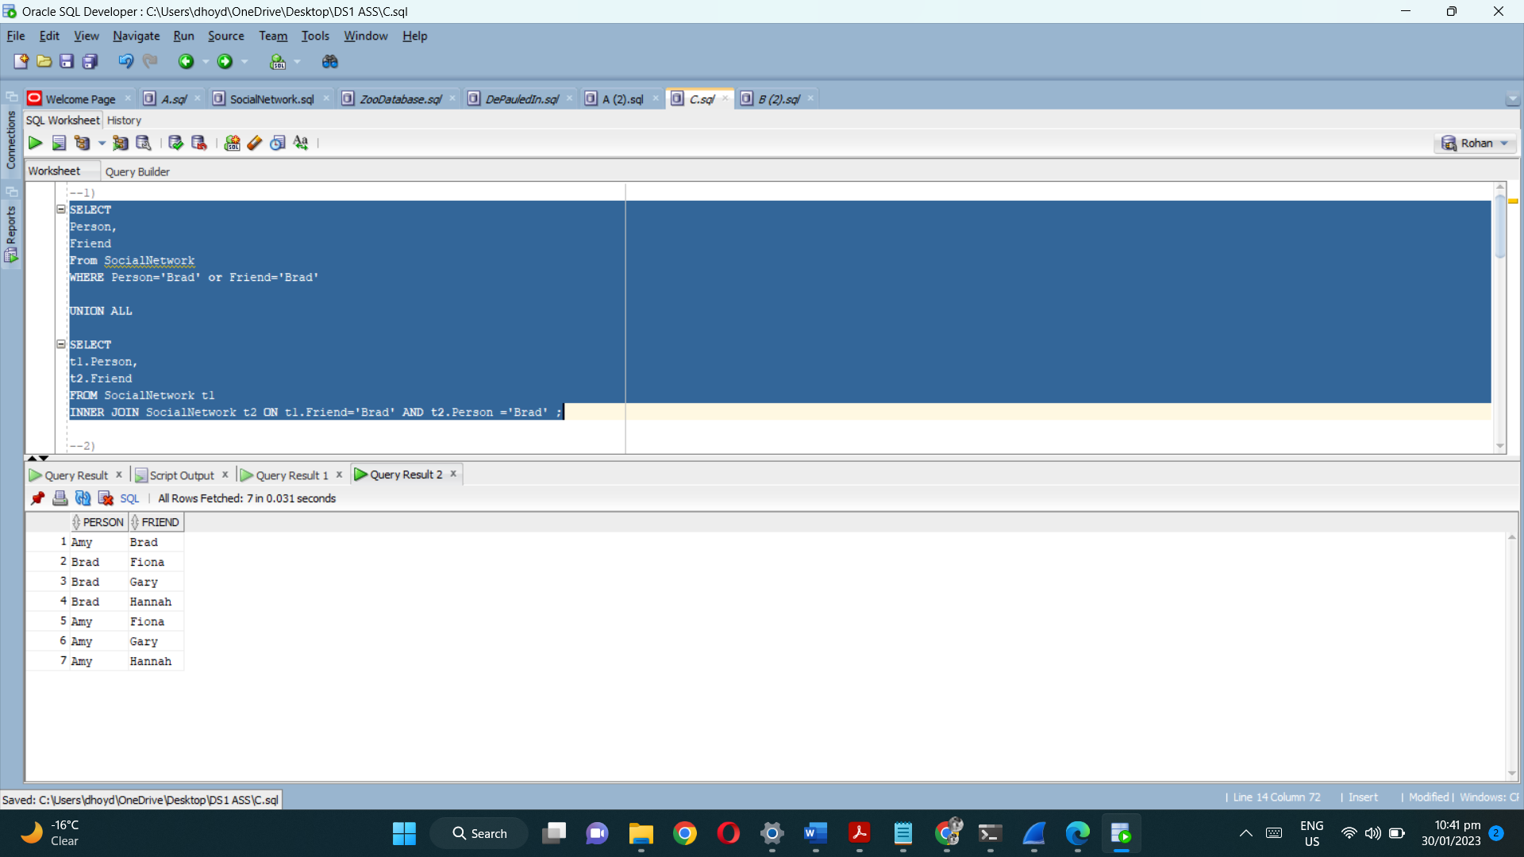

2)

3)

4)

